
Title: Raed Retro Store
Name: Raed Ahmed Alsafry
Student ID: 2236088
Section: CS1
Course: CPCS-403
Date: 25-10-5



Contents
Idea Description: 3
Recommended solution: 3
Benefits: 4
Sitemap: 4
Storyboard: 5
Database design: 6
Pages that we have added: 6
Features we added: 6

Idea Description:
Raed Retro Store is a nostalgic online platform dedicated to classic gaming fans. The website specializes in authentic retro games from PlayStation, Nintendo and Sega systems. The website allows the users to explore detailed information about each game, discover rare collectables, and experience the golden age of gaming. The website also connects enthusiasts by offering a contact form and a buy/sell request system.

Functions and Features:
- Home Page: Introduction, Store overview and featured products.

- Services Page: List of services like buying, selling, packaging and rare item requests.

- Items Page: Displays categorized retro games from (PlayStation, Nintendo and Sega) with descriptions and a buy buttons.

- Contact Page: Provides email, phone number and address detailed with a complane/feedback text box.

- Form Page: Collects customer information for buying/selling requests.

- About Page: Describe store goal, values and what people think about Raed Retro Store.

Recommended solution:
Raed Retro Store addresses the need for an online retro gaming store in Saudi Arabia. Instead of searching across may website users can easily browse categorized consoles view the images for authentication. The solution combines user-friendly navigation, nostalgic design and offer modern functionality.

Benefits:

- Easy access to multiple retro games platform in one place.
- Simple buy/sell form.
- Direct communication using the contact form.
- Nostalgic experience with the pixel style design.
- Accessible across browsers and devices.
- Safe way for collector to trade.

Sitemap:
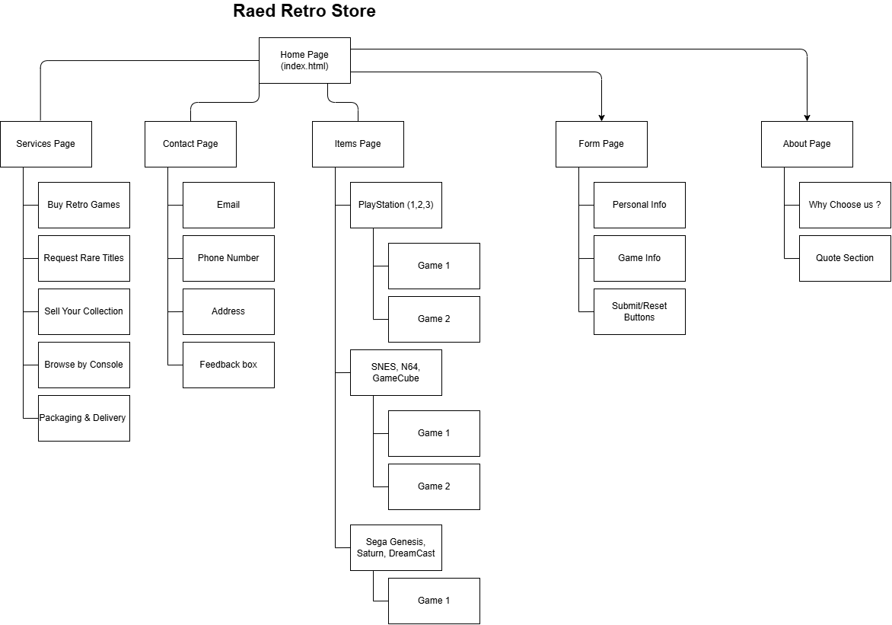

Storyboard:

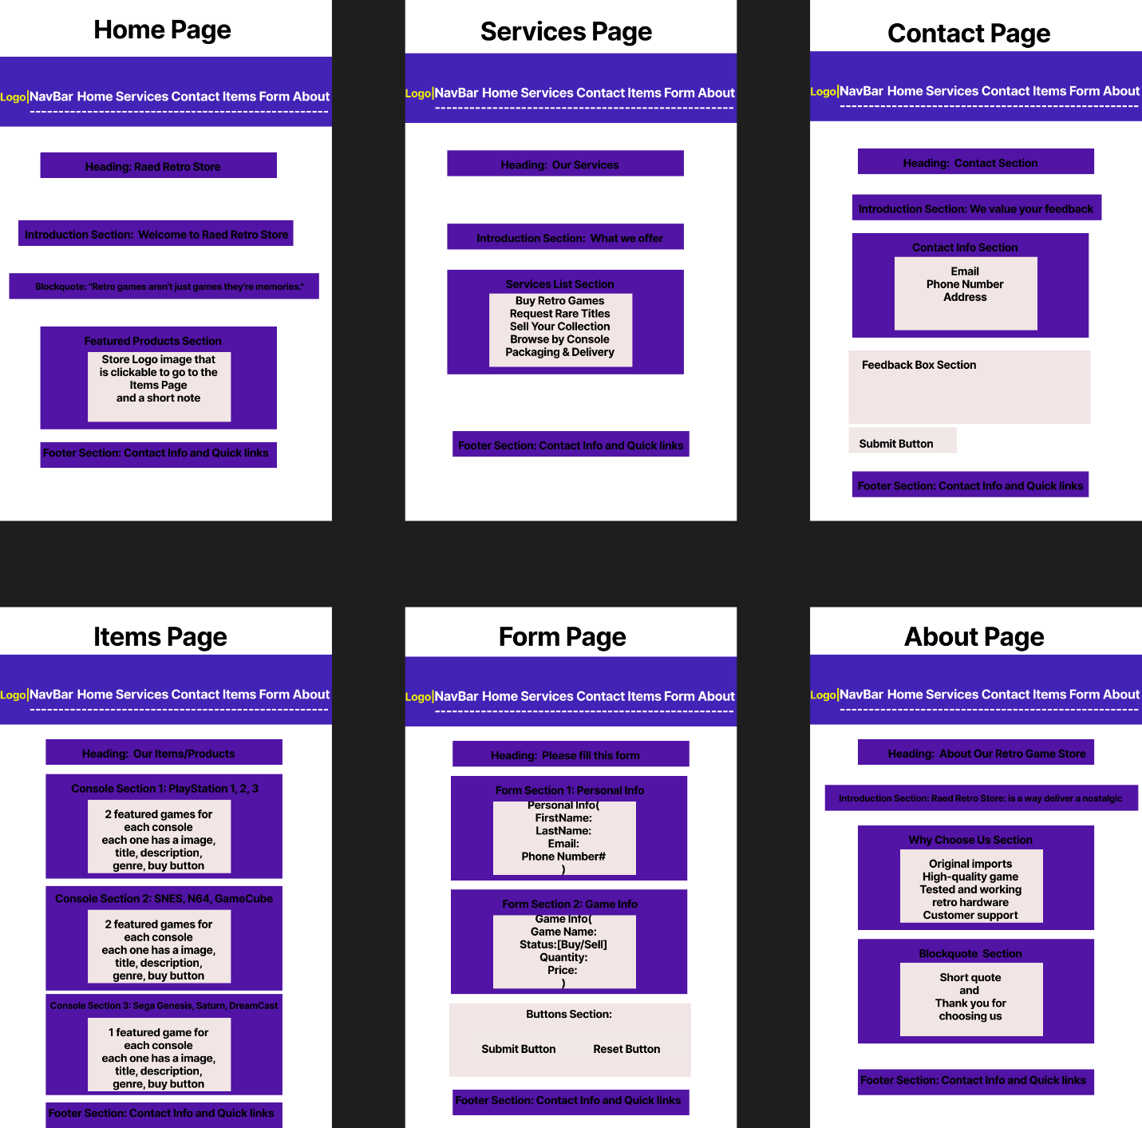

Database design:
- The name of the database is web_project.( You must make The name of the database web_project in sql for the website to work)
- We have made three tables: login table, complaint table, and form table.
- The login table is used to store the information of the users, and will be used for logging in. The primary key here is login id.
- The form table is used for complaints made by the user in the contact page. The primary key here is the form_id, and the foreign key that connects it to the login table is the user_id
- The form table is for the forms the user enters in the form page. The primary key here is the form_id and the foreign key that connects it to the login page is the user_id.

Pages that we have added:
- We added a couple extra pages. The pages were: photo gallery, table, video review, resume.
- Photo gallery: has the photo gallery that we implemented
- Table: It will have two tables. The first one will contain the forms that the user sent, the other will contain the complaints that the user entered from the contact page.
- Resume: Contains the pdf file for the resume.
- Video review: Will contain the external videos .
- Register: From here, the user will either create a new account or sign in to his account.

Features we added:
- We implemented the idea of sessions, this will allow the user to stay logged in even if he moves between different pages.
- Buttons for log in and log out
- The form, contact page, and the table page will be closed until the user enters his account or create one.

